**Jimma University**



**Jimma Medical Ceneter(JMC)**

**Software Manual Documentation**

**Integrated HCI System**

**Mr. Seid Mohammed**

[**seidm9815@gmail.com**](mailto:seidm9815@gmail.com)

**0917638874/0985192541**

**JMC-ICT**

**2019**

**Table of Contents**

1. System Title: Integrated HCI System 4

2. Accessing Integrated HCI 4

2. System Home Page 5

3. New Patient Registration module 6

4. Batch upload and View all Patients 7

5. Search module 8

5.1 Unsuccessful search result 8

5.2 Successful search Result 8

6. User account Management 10

7. System Statistics 12

8. Communication module 13

9. Profile Management 14

10. Report Generation 15

11 Registration new User, Region, Zone, Woreda and Kebele 17

11. Language configuration 18

12.1 Adding new Language 20

12. Database Backup and Restore 20

Major Function Integrated HCI Application

1. Patient Registration with:

* Credit service
* CBHI patients
* Health care finance

1. Search service for patient using patient medical record number or using personal ID or mobile number.
2. User account management and monitoring module
3. System statistics
4. System configuration and parameter setting
5. Communication module using text message with any registered users
6. Profile management
7. Report Generation
8. Monthly reports
9. Quarterly reports
10. Personal treatment reports
11. Notice board
12. Registration of new:
13. Regions
14. Zones
15. Woreda
16. Kebele
17. Language configuration English and Amharic
18. Database backup and Restore
19. All finance information
20. Patient Batch upload with huge Excel file

# System Title: Integrated HCI System

Integrated HCI System stands for Health care finance, Credit service and Community based health Insurance together that focus on payment request report monthly and quarterly, quick search patient profile, collection service charge.

# Accessing Integrated HCI

HCH is a web application that can be access using any browser such as Google chrome, Firefox, IE, Sefari, Opera and others

  and more

* 1. Login page: user can accessing the system using

1. Username or Email
2. Password

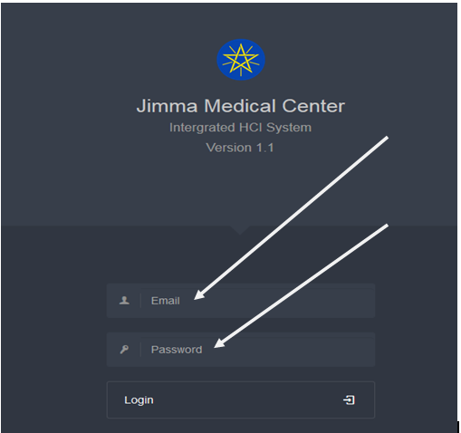

# System Home Page

After the user has been logged in to the system the following page will web displayed.

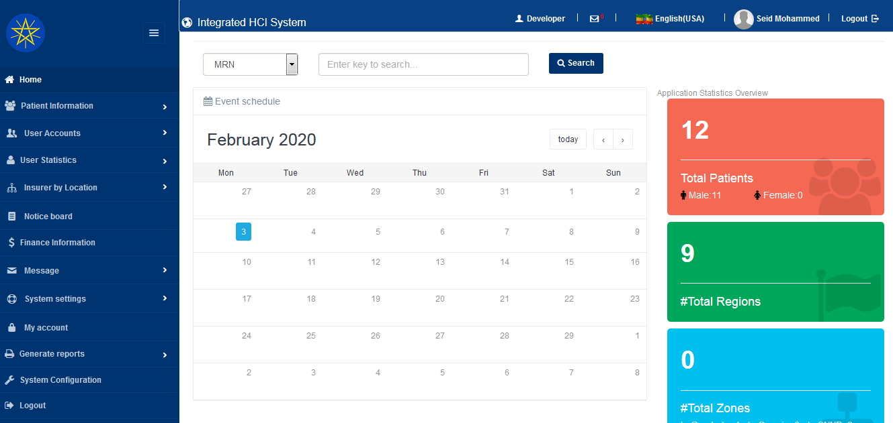

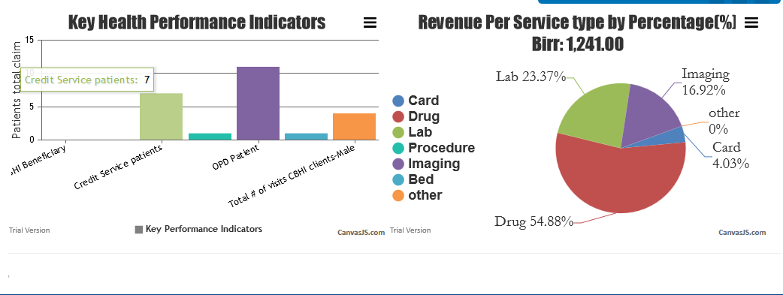

# New Patient Registration module

In order to register to new patient click ‘’ new patient’ link then registration page will be displayed. among credit service ,CBHI and Health care finance.

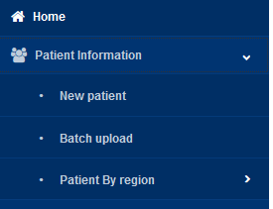I

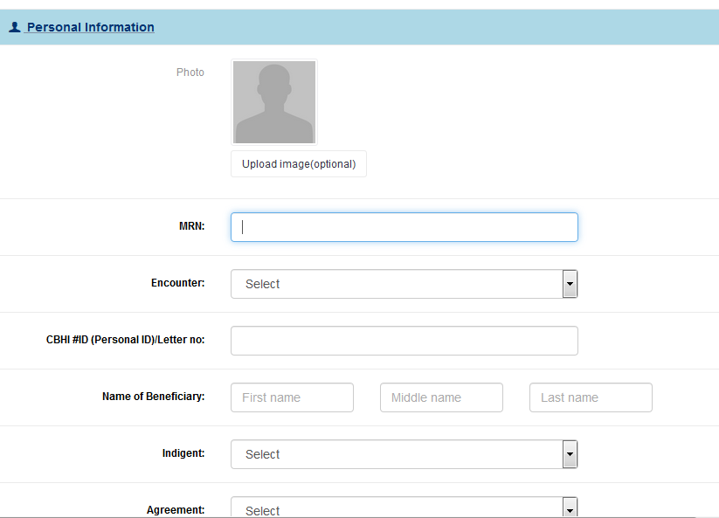

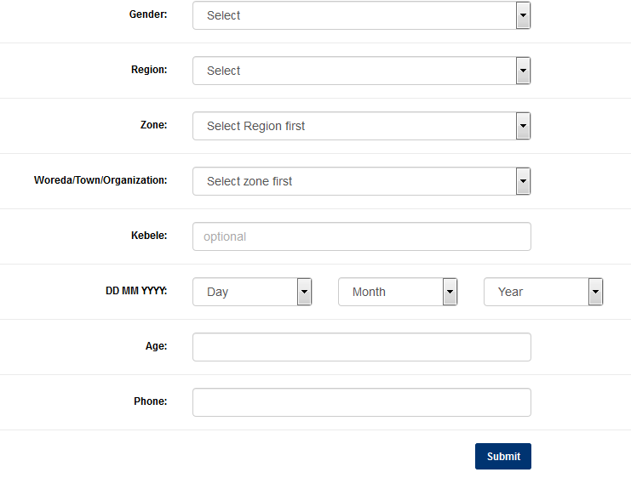

# Batch upload and View all Patients

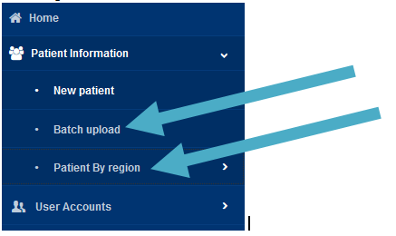

# Search module

The user can search already registered patient all credit patient, health care finance using phone number, medical record number(MRN) or CBHI #ID of search bar below:

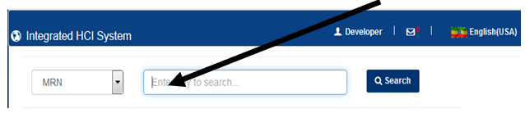

## 5.1 Unsuccessful search result

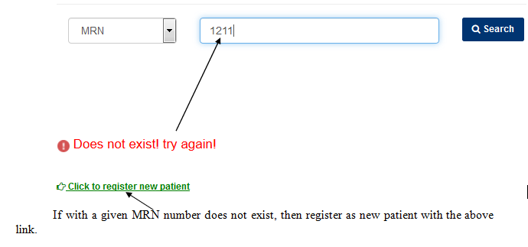

## 5.2 Successful search Result

After filling required information among phone, CBHI #ID or patient Medical record(MRN). If entered unique ID match with the database, the system display patient profile as follow:

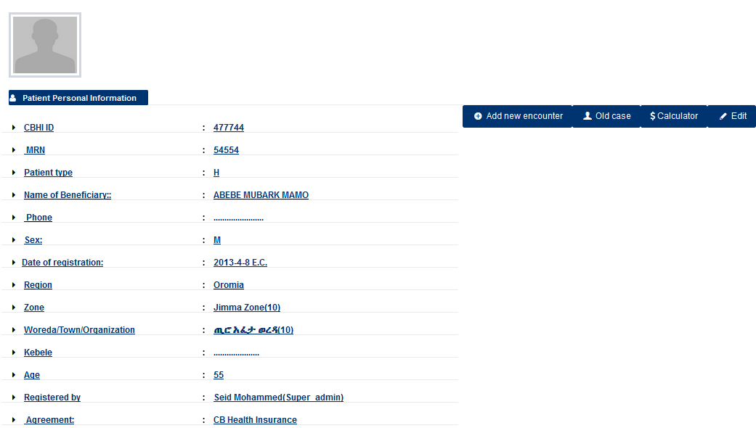

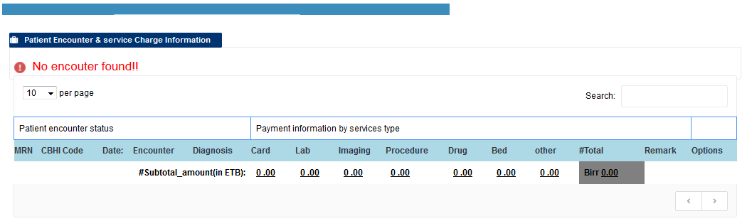

Under this patient profile, the user can do the following transaction based on the privileges.

1. Create new encounter
2. Add service payment
3. Calculate total service cost
4. Edit patient profile and encounter
5. View treatment and encounter history.

# User account Management

User account management module prepared for system administration purpose in the following cases:

1. Creating user account
2. User activity monitoring
3. Password resetting
4. Checking access control(User IP address, browser and login trials)

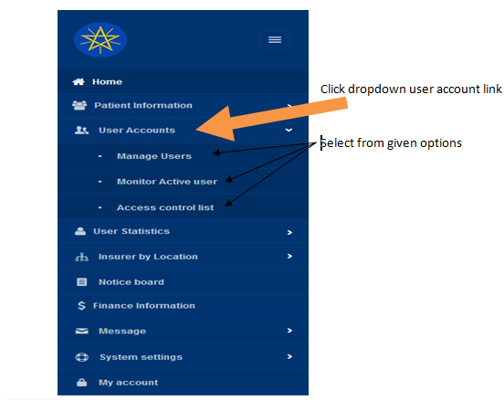 click under “Action”

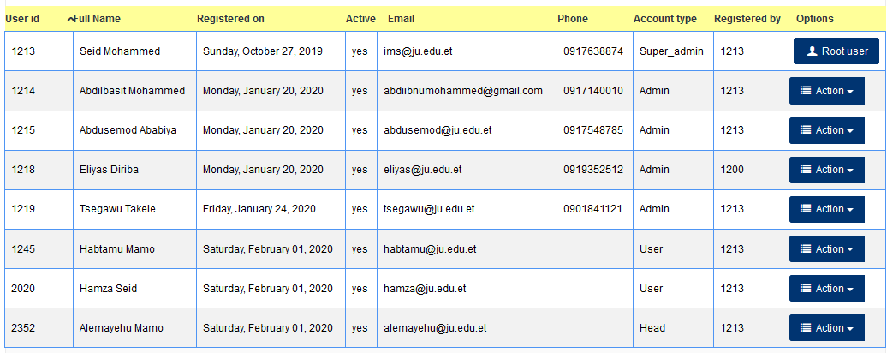

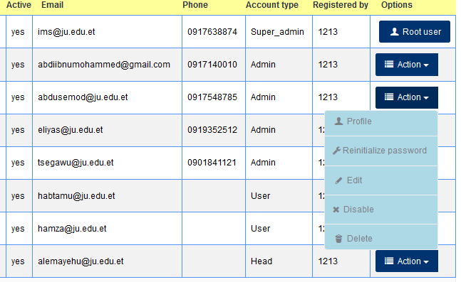

Under User management tools at the right side of user table, there list above action profile, Re-initialized password, Edit, Disable and move to trash or delete. Those action always carried out by system administrator or super administrator.

1. **Profile:** this action enable system administrator to view user more details which are registered by admin.
2. **Re-initialized password :** When the user forgot their password, the system administrator will re-initialize to default password “jimma” the user able to login into the system that will be change password based on user need.
3. **Edit:** this action also used to update user profile while it is necessary to change already filled as new.
4. **Delete:** This a strong admin tool can be done only by super admin when it is necessary to move trash while employee or user leave the hospital.

# System Statistics

The system information module which found mostly on dashboard the includes

1. Numerical Patient classification by gender
2. Number of Regions , zone, districts and kebeles with graph
3. Contracted woreda and organization with respective zones indication.
4. Total hospital revenue from community based health insurance, health care finance and credit service.
5. Provide percentage information by service type from Card, Laboratory, drug, procedure, imaging, bed and others using pie chart.
6. Key health performance indictor using bar graph for the following factors;

* CBHI beneficiary
* Credit service patients
* Health care fiancé users
* OPD visitors
* IPD admissions
* CBHI By gender # female and #Male

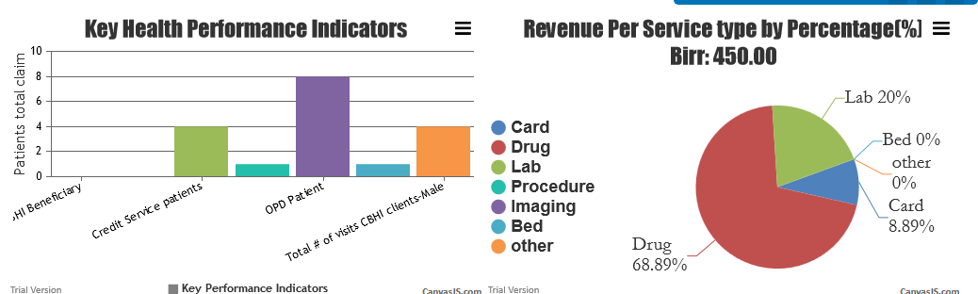

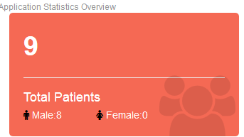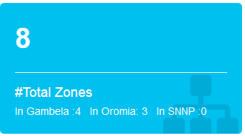 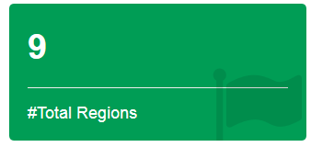 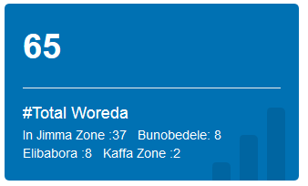

# Communication Module

This sub system enable to any user to send private text message to any registered user on the system. It has message threads which allow users to communicate each other.

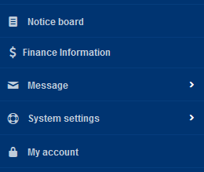 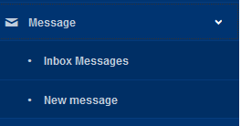

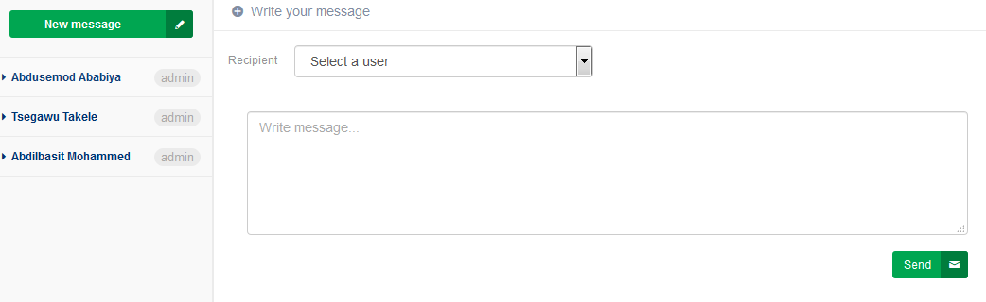

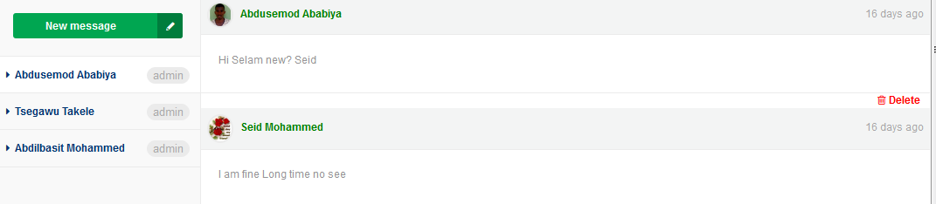

# Profile Management

This module enable user to modify their own user account including

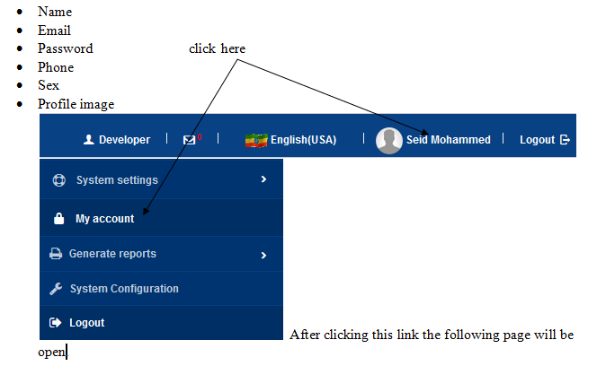

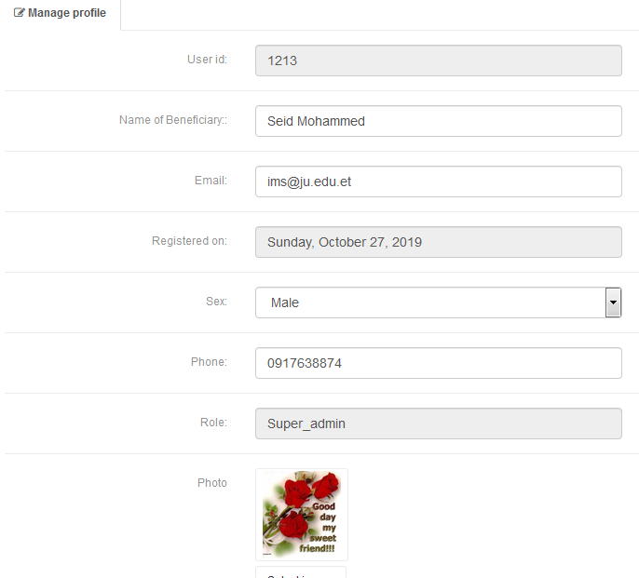

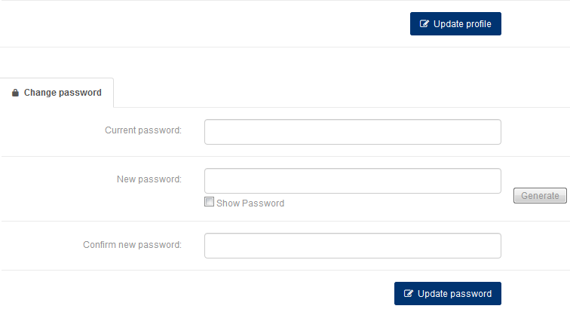

# Report Generation

This sub system is very important part of the system that is solve server problems of manual or paper work related to finance. The report can monthly or quarterly report that request payment to districts or organization. This allow the hospital to get its revenue timely with any error made as paper report.

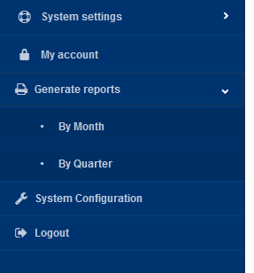

When clicking By Month the following page will be displayed

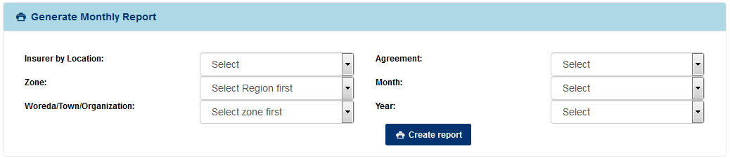

1. **Insurer by location**- You have to select patient region fields. There are all Ethiopian regional states available in selection option.
2. **Zone -** This selection option depends upon previous selection input above
3. **Districts or Orginzation-** Base on the selection above zone, there will be displayed different woreds and organizations to be selected that indicate patient address.
4. **Agreement:** this selection can be only three alternatives community based health insurance, credit service and health care finance. Based on patient type the user must be select from given options.
5. **Month:** this is also the month of report from September up to August from given year.
6. **Year:** The user must select year of report.

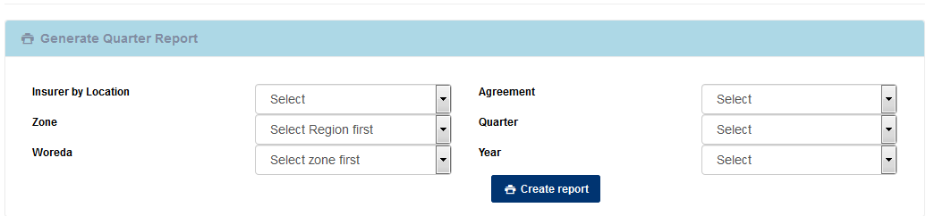

1. **Insurer by location**- You have to select patient region fields. There are all Ethiopian regional states available in selection option.
2. **Zone -** This selection option depends upon previous selection input above
3. **Districts or Orginzation-** Base on the selection above zone, there will be displayed different woreds and organizations to be selected that indicate patient address.
4. **Agreement:** this selection can be only three alternatives community based health insurance, credit service and health care finance. Based on patient type the user must be select from given options.
5. **Quarter:** this is also the quarter of report from consecutive three months started from September
6. **Year:** The user must select year of report.

# 11 Registration new User, Region, Zone, Woreda and Kebele

1. 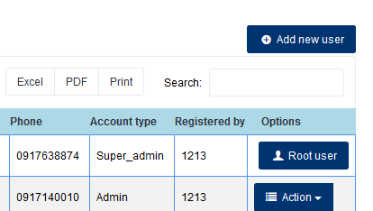

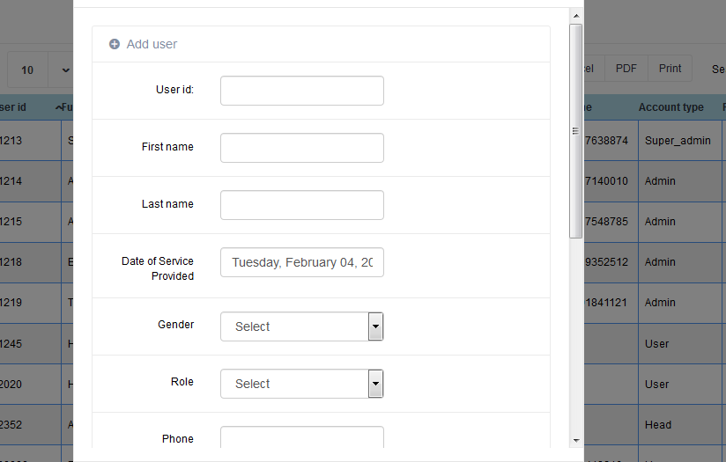

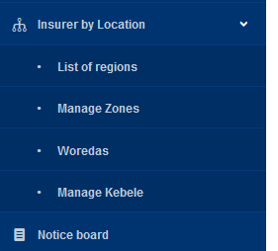

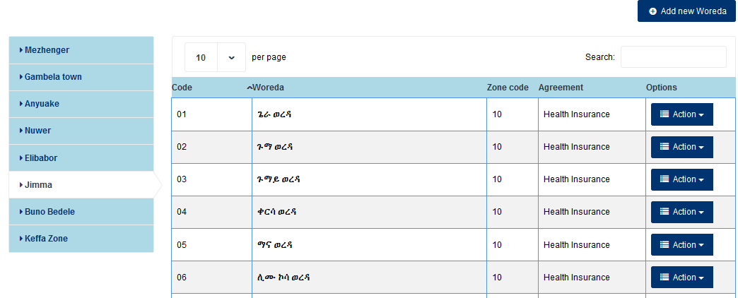

# Language configuration

Currently integrated HCI System contains two alternative languages namely English (USA) and Amharic official language of Ethiopia. Another language will be added upon request. So the users work on the system using their understandable system language. So Afaan oromo language will we added in next 2.1 version.

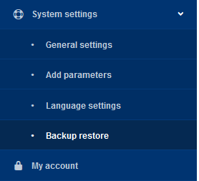 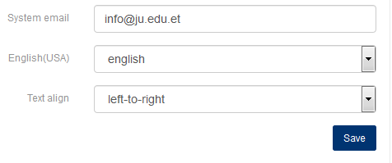

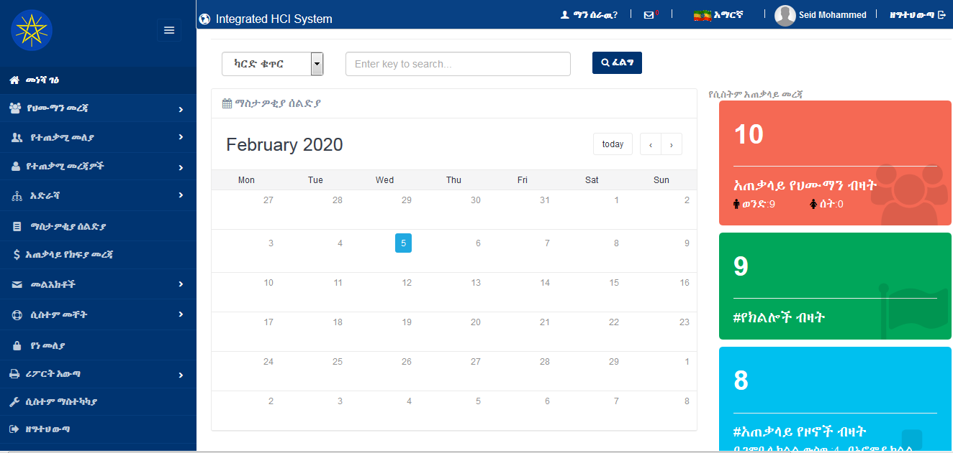

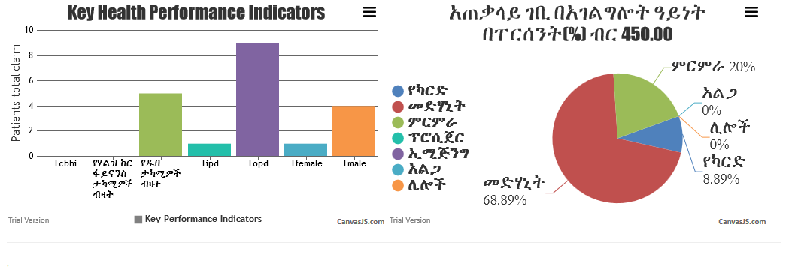

## 12.1 Adding new Language

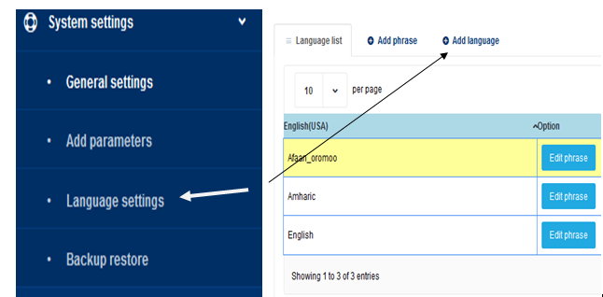

# Database Backup and Restore

